Connecting to MS Azure
Configuring the database

Linking to the Database 1
MS Azure 1
How this will Work – Copy and Adapt 1
Creating your Account 1
https://azure.microsoft.com/en-us/free/students/ 1
Creating your Database 2
Servers 2
Databases 2
Tables 2
Stored Procedures 3
Managing your Database 3
Using the Web Portal 3
Creating your Database 3
Using Visual Studio as the Database Owner 10
Checking the Connection 12
Accessing the Database for Other Team Members 14
Creating Tables 16
Adding Data 23
Creating Stored Procedures 23
Testing the Stored Procedure 25

Linking to the Database

MS Azure
As a student you have access to a (sort of) free Azure account. The idea is that you are given $100 of credits which, following these examples should easily last you through the year.
I would suggest that in your team you nominate one person who is going to be the account holder. It is on their account that the server and database needs to be created.
This person will create an SQL server database with a username and password, the name of the server, database, username and password need to be distributed to members of the team.
Azure is a platform that allows you to publish web applications and services running under a range of different technologies.
For this work we will concentrate solely on using Azure to provide back end database functionality.
Working as a team, Azure provides the big advantage that each team member may connect to and use the database simultaneously. In other alternative configurations there is the risk of having multiple copies of the same data (one database for each team member) along with the risk of locking all members out of the system while one person is editing the schema.
Being a web based service Azure is also available wherever you have access to the internet rather than say only being available on campus.

How this will Work – Copy and Adapt
In these notes I will present you with examples of what your code might look like. I will typically use the example of creating an Address Book. You are likely to be working on something quite different though. If you are working on the stock part of your system you will need to adapt my examples such that they work for you. Do not simply copy my examples as they stand!

Creating your Account
Your first task will be to sign up for your student account. Make sure when you do this you use your University email address.
Azure is available here...

https://azure.microsoft.com/en-us/free/students/

I would suggest that one team member takes on the role of owning the account. Given that you will need to share your password with your team members I would suggest that you do not use a password that you are using for all other accounts!

Creating your Database
Once you have created your student account you should find yourself at something like the following page...
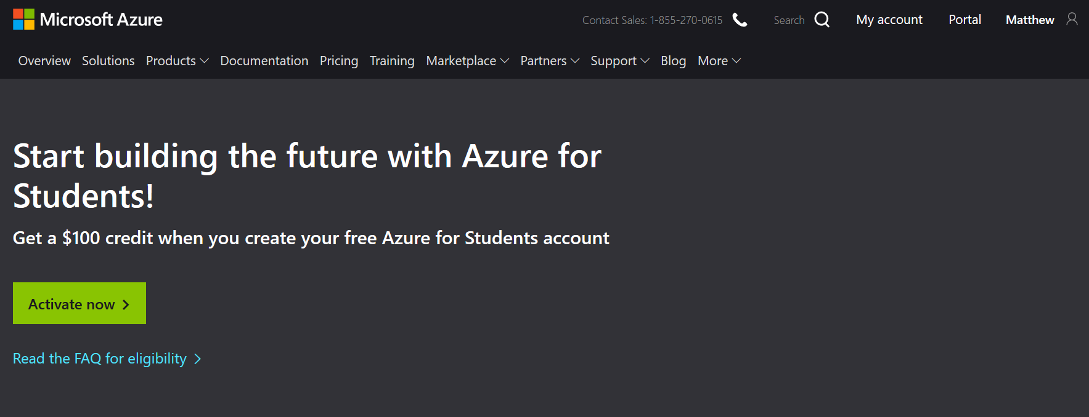
To set up servers and databases you need to manage your resources via the Azure portal...
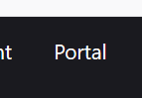

Servers
In order to make this work you will need to create a few resources to host your database.
The first resource you will need to configure is a server. A server is a computer (at Microsoft) that will host your database files(s).
The server can be called whatever you like so long as the name hasn’t already been taken.
You will set up a username and password for the server which your applications will need to provide to access the databases it hosts.

Databases
The database is a named data store which will contain your tables and stored procedures for managing your data.

Tables
Tables will store the raw data for your system.

Stored Procedures
Stored procedures will contain code written in SQL allowing you to manipulate the data in your tables. All interactions with the data will be via stored procedures and never by directly accessing the tables.

Managing your Database
There are three different systems we need to configure in order to access your database, they are...
- The Web Portal – for creating the server and database
- Visual Studio – for creating and managing tables, stored procedures
- Data Connection Class – allowing your code to access the functionality provided by your stored procedures

Using the Web Portal
The web portal is available on-line at https://azure.microsoft.com
The web portal is used mainly for setting up the server, creating your database and also managing firewall rules allowing your local machine to access the server.

Creating your Database
From the main page of the portal select the option Create a resource...
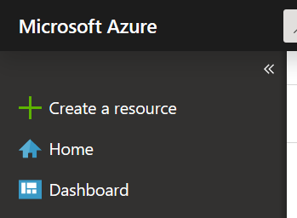
Find the section for SQL Database and click it...
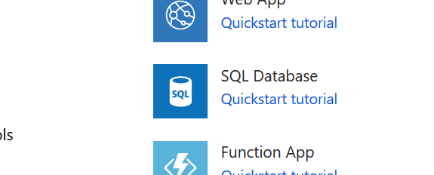
You now need to decide on the name of your server and the name of the first database, it is best to agree this as a team with one member hosting the server.
The first section of the form allows you to check that you have the right subscription set up and also selecting the resource group to use...
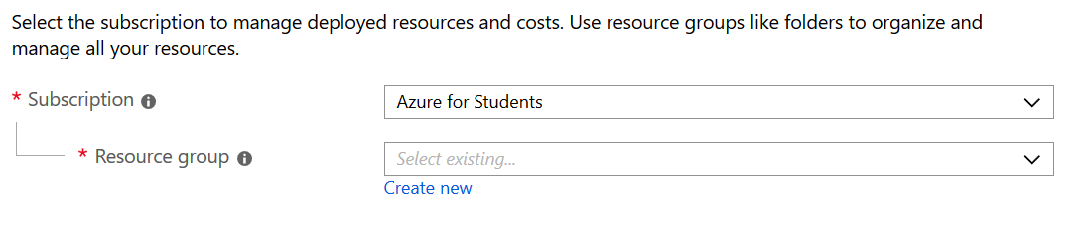
For resource group you may find that “MyResourceGroup” is already on the drop down list, if so select it, if not create it.
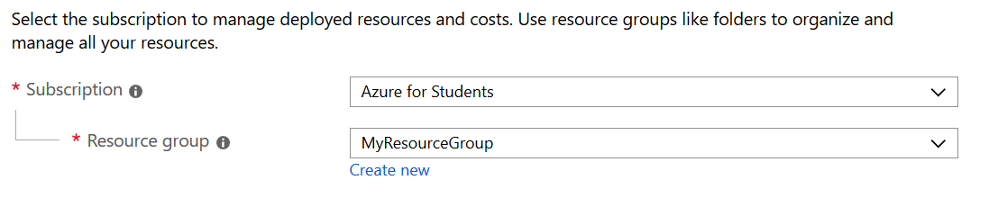
The next section allows us to set the name of the database and the name of the server. In this case we shall set the database to AddressBook and you need to decide on a suitable name for your server by selecting “create new”.
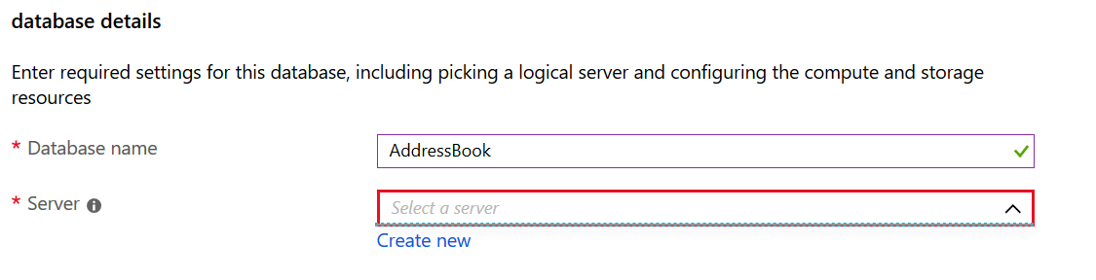
This will then ask you to complete the following options...
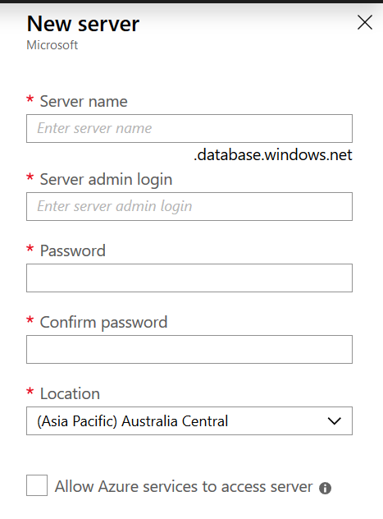
Complete the entries and make sure you keep a note of them passing the details to all members of your team.
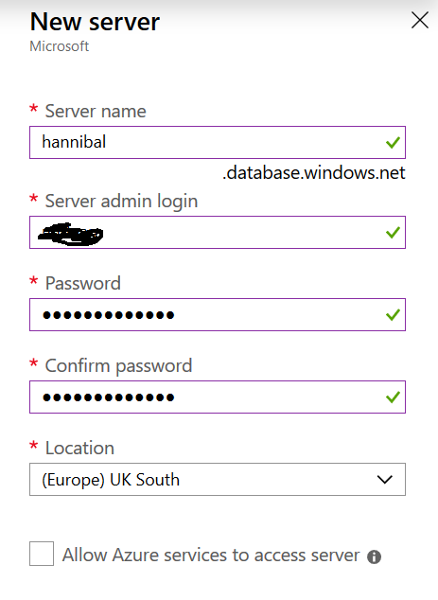
Press Ok when done.
The next options allow us to configure the database...
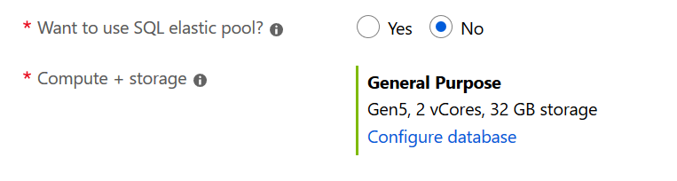
Leave SQL elastic pool at No and click the link to configure the database.
The option you want here is this one...
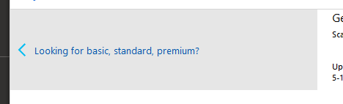
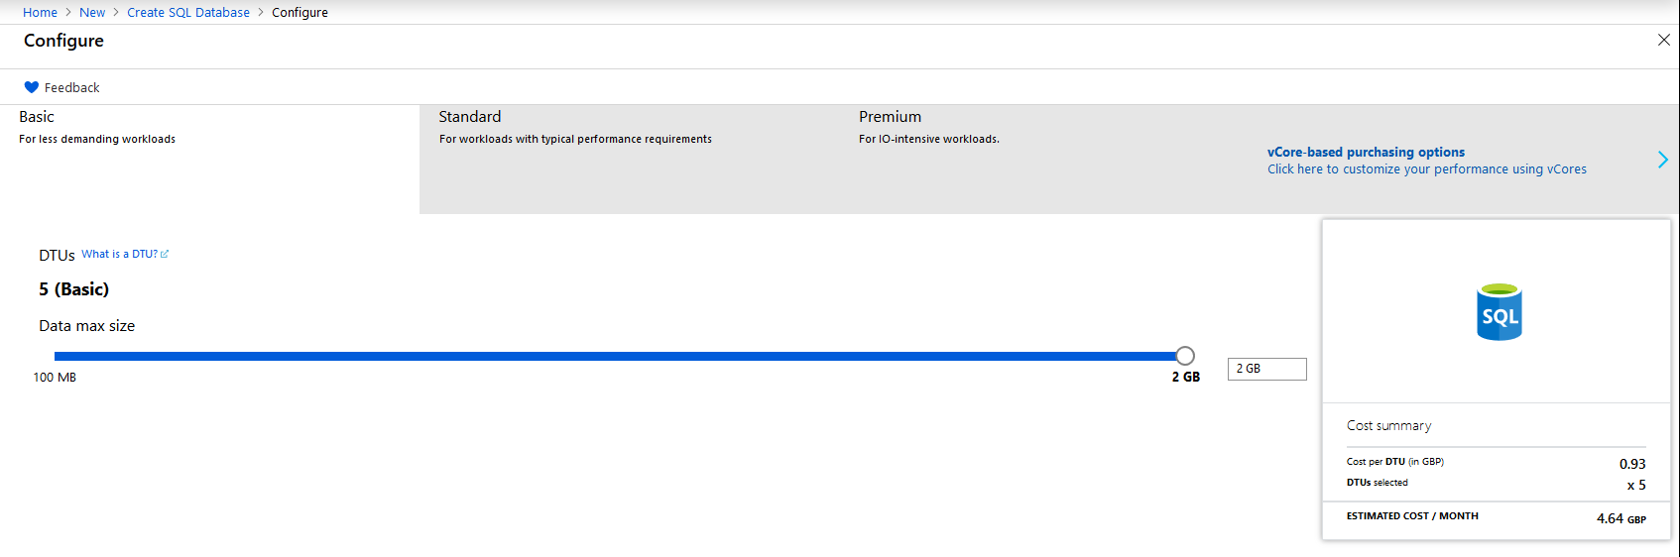
Once selected press apply...
You should see the following...
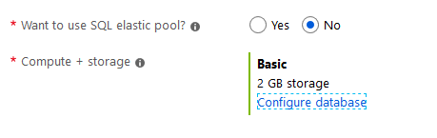
Next press additional settings...

Set up this page with the following options...
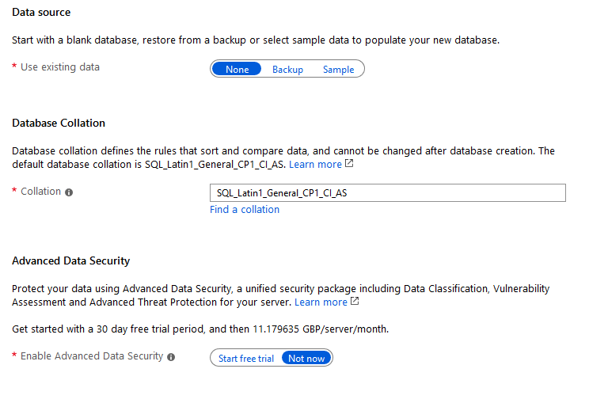
Press next : tags...

Leave the following page as it is...
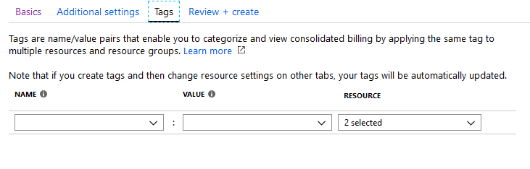
Press Review + Create....

The most important item on this page is to make sure you haven’t accidentally selected a super expensive pricing plan; it should look like this...
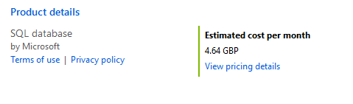
If it doesn’t then double check the setting or ask your tutor.
Lastly press create...

You should see activity notifications at the top right of the page...
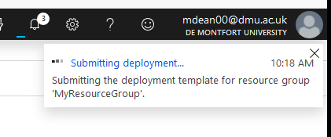
This process may take a little while.
(If you want something to do try hitting refresh a few times!)
Once the system is done you will be able to see your resources under “All resources”...
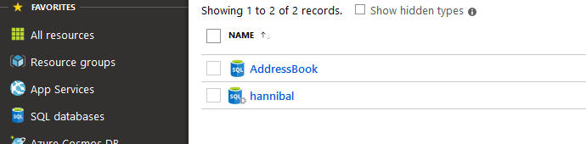
For the next step we need to access the database from Visual Studio, don’t close the portal yet as we may need to adjust some of the security settings.

Using Visual Studio as the Database Owner
Open Visual Studio and access the server explorer...
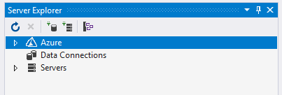
By selecting the correct tab at the bottom of the window...
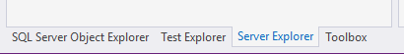
Right click on Azure and select the following...
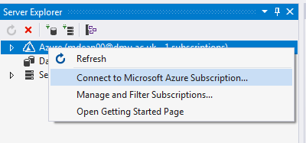
This will take you to the main login screen for Azure in Visual Studio...
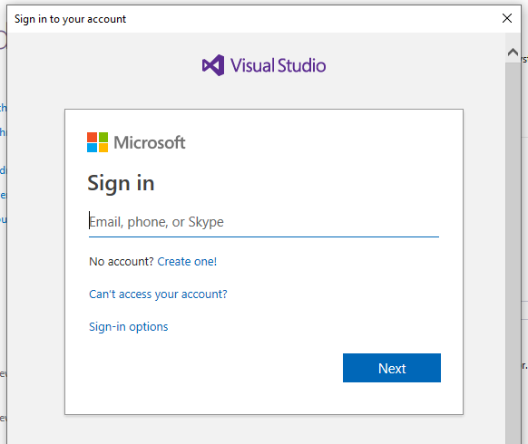
Once signed in you should be able to see your server and database in server explorer...
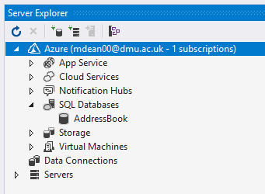

Checking the Connection
Right click on the database and select the following...
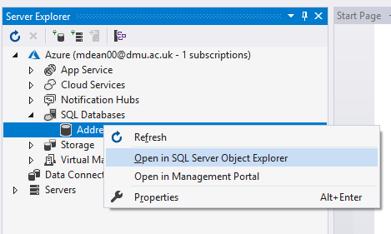
At this stage we have a good test to make sure that the firewall at Azure isn’t blocking access from our client machine.
You may encounter the following error...
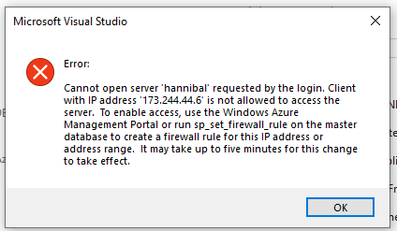
If this message appears you will need to go back to the Azure web portal and allow access for your client machine.
Under all resources click on the server you created above...
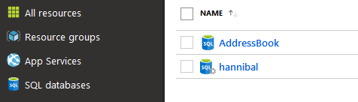
In the central menu find security and click on “Firewalls and virtual networks”...
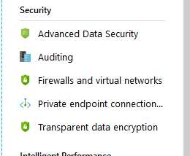
You should see the following screen...
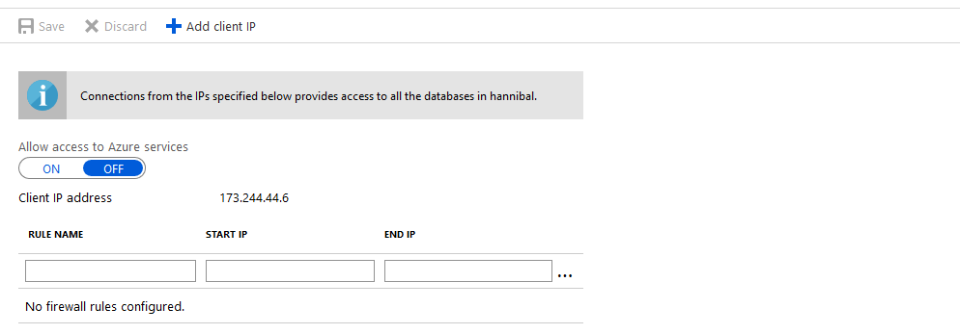
Press “Add client IP” to tell Azure that this local machine is allowed access, the client IP address will be added as a firewall rule...
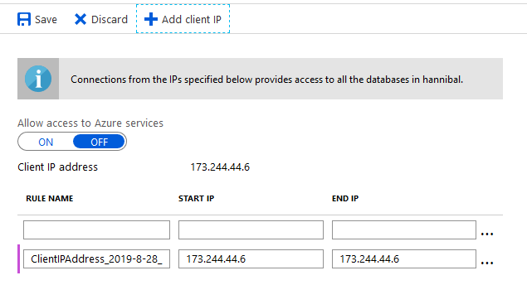
Next press save.

Accessing the Database for Other Team Members
The database owner will have access to the database as part of their Azure account. The main Azure account is accessed using your PNumber and University password, these details should not be given out to other team members!
For each team member to access the database they will need the name of the server, user name and password created above. (You should have made a note of this.)
In the SQL Server Object Explorer right click on SQL Server and click Add SQL Server...
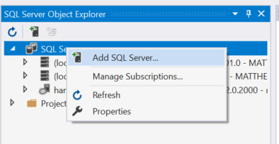
This will provide you with the following log in page...
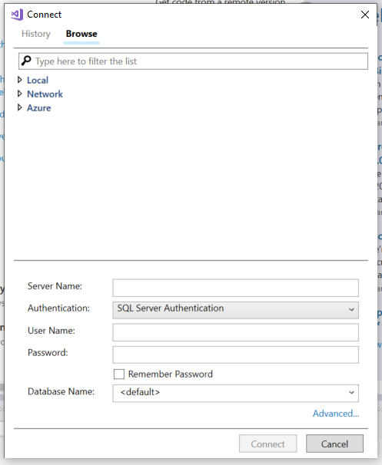
Make sure that authentication is set to SQL Server Authentication.
The Server Name will be something like {servername}.database.windows.net where {servername} is the name you have given your server.
User name and Password are those created by the server owner, and then press connect.
Try accessing the database through Visual Studio and you should now be able to navigate the structure...
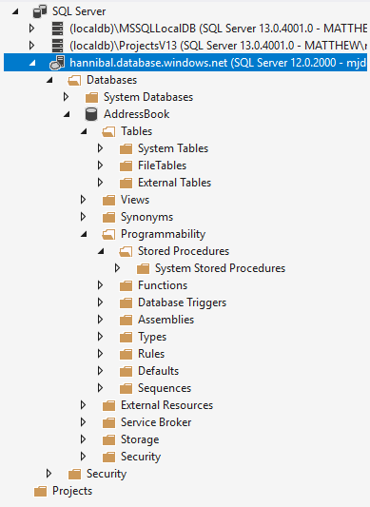
At this stage expand the sections for “Tables” along with “Programmability – Stored Procedures”

Creating Tables
The next resource we need to create is a table to store some data in.
From the SQL Server Object Explorer, right click on the section marked tables selecting “Add New Table”...
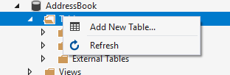
After a bit of waiting you will be presented with the following screen...
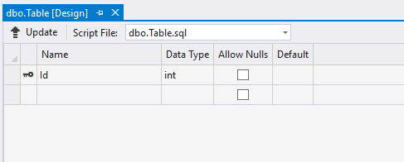
We will set up a basic table to store our list of counties.
First, set the name of the table by modifying the SQL at the bottom of the window setting the table name to tblAddress...
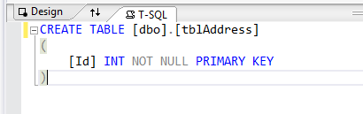
(“tbl” is just a naming table to remind us that this is a table!)
The next step is to create the fields for the table in the top section like so...
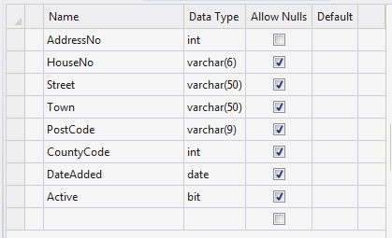
The column called Name identifies what the name of the data stored in the field. The column called data type identifies what sort of data we are allowed to store in that field.
For example,

Int short for Integer meaning whole numbers. E.g. 1,2,3,-40, 100 NOT 4.5, 55.8 as these are decimal numbers.

Varchar(6) Any combination of letters or numbers up to 6 characters

Date Any valid data

Bit True or False only

When creating field names, it is always a good idea to consider the following:
Avoid spaces AddressNo is better than Address No
Avoid unusual characters # ~ ! etc..
Use pascal naming convention AddressNo clearer than addressno
Avoid certain reserved words date, password (+ others)
Now that the fields have been set up we need to do two more things.
The field AddressNo is going to be the primary key for this table and will be used to uniquely identify each record in the table.
The first step is to make sure this value is unique. To do this we set it as the identity of the table so that the database will generate this value.
Click once in the name of the field to select it...
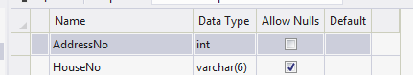
In the bottom, right hand corner of the program are the properties for the field. Find the property called Identity Specification and expand it...
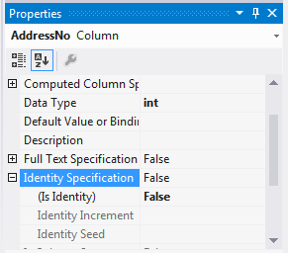
Change “Is Identity” from False to True like so...
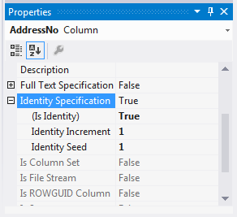
This has set the field such it starts at 1 (identity seed) and for every new record the numeric value increases by 1 (identity increment).
The last step is to set this field as the Primary Key for this table.
Right click to the left of the field name and select Set Primary Key...
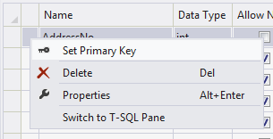
The definition for the table should now look like this...
CREATE TABLE [dbo].[tblAddress] (
[AddressNo] INT NOT NULL IDENTITY,
[HouseNo] VARCHAR (6) NULL,
[Street] VARCHAR (50) NULL,
[Town] VARCHAR (50) NULL,
[PostCode] VARCHAR (9) NULL,
[CountyCode] INT NULL,
[DateAdded] DATE NULL,
[Active] BIT NULL,
CONSTRAINT [PK_tblAddress] PRIMARY KEY ([AddressNo])
);
Now that the code to create the table is set up we need to create the table.
In Visual Studio press the button that says Update...
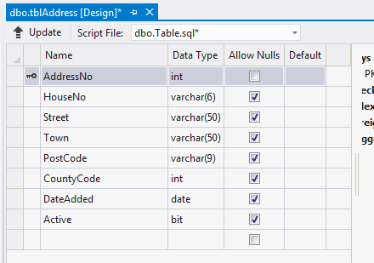
After a second or two the following screen should appear...
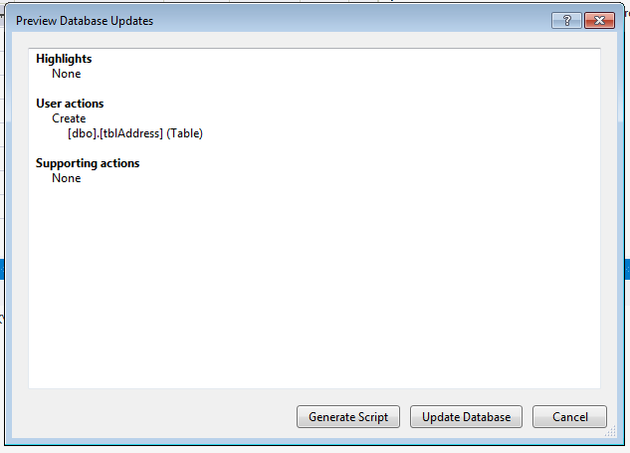

To create the new table, press Update Database.
Your table should now be visible, if not right click on the tables branch and select refresh...
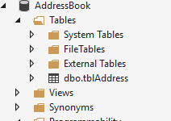

Adding Data
The next step is to add some data to your table to make sure it is working.
In the server explorer right click on the name of the table and select show table data.
This will give you a screen allowing you to add new data to the table.
Notice as you add the data the value for the AddressNo field is updated automatically by the database...
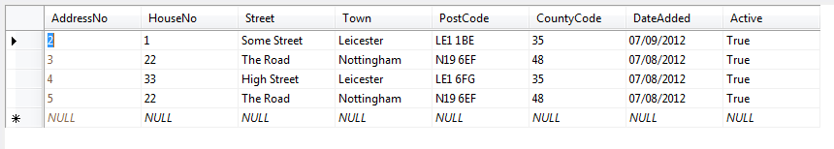
Add a few records so that we have some data for the next stage of the work.

Creating Stored Procedures
As mentioned above we will not be accessing the table directly with our code but using a stored procedure. One of the biggest advantages of this approach is that of increased security.
Creating a stored procedure is a very similar process to creating a table.
In the SQL Object Browser right click on the stored procedure branch and select “Add New Stored Procedure...”
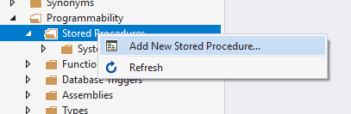
After a little while you should see the following screen appear...
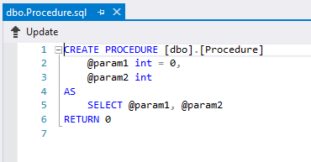
Modify the SQL code as follows...
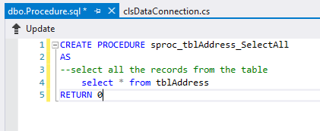
As in the case of a table you must press update to make the changes to the database structure.
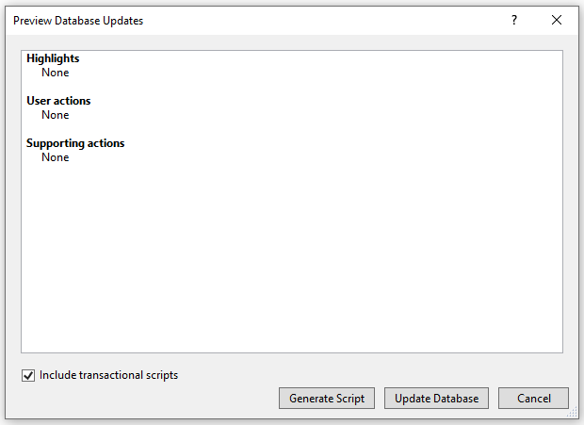
You should see the stored procedure in the tree structure of the database, if not try refreshing it...
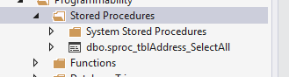

Testing the Stored Procedure
To make sure the stored procedure is working right click on it like so...
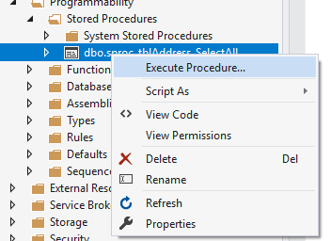
You should see the data from the underlying table displayed.
Close the query output window, don’t bother saving it.

